**Day-19, 21-Apr-2025,Monday**

**Topic:** **Introduction to DevOps and CI/CD Pipeline (3 days)**

**Devops :**

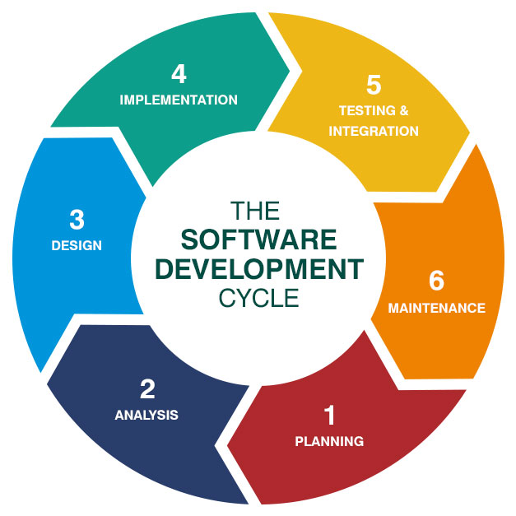**SDLC Life Cycle:**

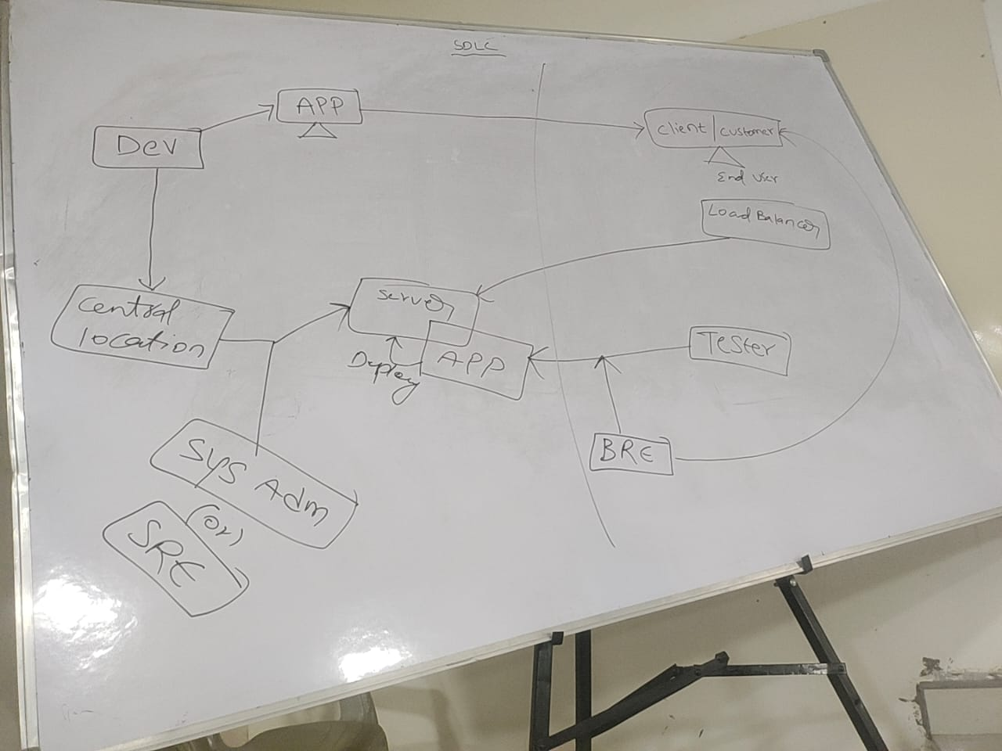

**HLD:**

**Project Manager**

**LLD:**

**TL**

**Employee**

|  |  |
| --- | --- |
|  |  |
|  |  |

**Building**

**There are 8 phases in dev-ops**

1. **Plan**
2. **Code**
3. **Build**
4. **Test**
5. **Release**
6. **Deploy**
7. **Operate**
8. **Monitor**

# Jenkins- C I C D pipeline

**Programing-**

**Coding-implementing logic**

**Branching Strategies in git:**

**CI -Continuous Integration ,CD -Continuous Deployment And Delivery**

**SRE-System Reliability Engineering**

**CDN- Content Delivery Network**

**Hashing—to reduce the latency ( balance loading)**

**There are 3 types of branches:**

1. **Main/Master**
2. **Feature**
3. **Release**
4. **Bug fix/hard fix**

**Main/Master branch**

**Feature**

**branch**

**Release branch**

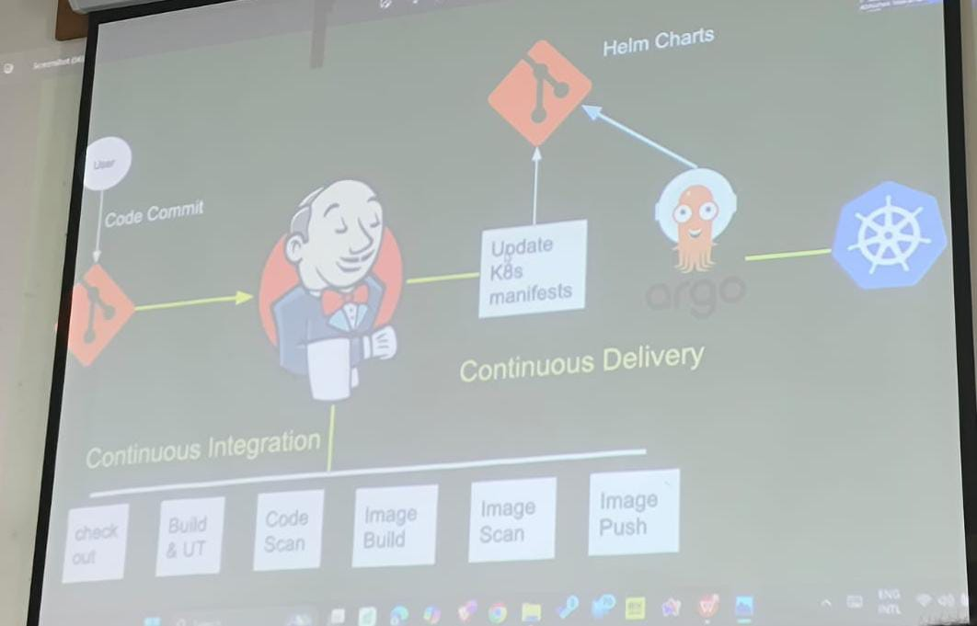

1. **Check out the code**
2. **Build And unit testing**
3. **Scan the code**
4. **Image build(done by docker)**
5. **Image scanning**
6. **Image push**

### Interview questions:

[**https://chatgpt.com/c/6805e8c4-4388-8011-92ff-959a9142239a**](https://chatgpt.com/c/6805e8c4-4388-8011-92ff-959a9142239a)

1. **explain difference between dot net and dot net core**

# asp dotnet core vs mvs/web api

1. **explain mvc pattern in asp dot net core**
2. what are the differences bettween asp dot net and
3. explain middle ware in asp dot net and its functionalities
4. explain different ways of authention and authorization in dot net core
5. hoe do you configure CORS in asp dot net core
6. explain model binding and validation in asp dot net core mvc
7. how do you implement hashing in asp dot net core
8. what are the best practices to improve performances in asp dot net core appkications
9. discuss lodin mechanisms available in asp dot net core

**basic work flow of a git:**

1. **You modify a file from the working directory**
2. **You add the files to the staging area**
3. **You perform commit operations that moves the files from the staging area**

**(After push operation it stores the changes permanently)**

Staging area

Working directory

Git commit

Git add

Git repo

# Staging area:

**An intermediate area where commits can be formatted and reviewed before completing the commit**

|  |  |  |  |
| --- | --- | --- | --- |
|  |  |  |  |

|  |  |
| --- | --- |
|  |  |

|  |
| --- |
|  |

|  |
| --- |
|  |

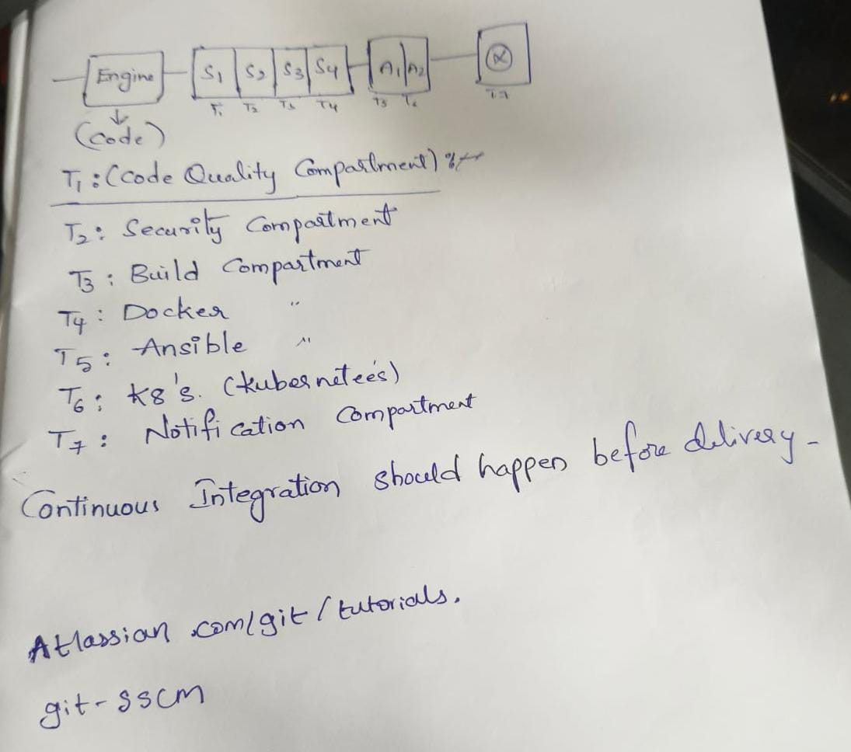

## Major services offered by AWS services:

1. **EC2 -elastic cloud compute**

* **It is a elastic cloud compute,a service from aws.**
* **Its like renting a computer in the cloud.**
* **You can get computing power,whenever you need it without buying a physical machine.**

1. **RDS-Relational database service**

* **It is like a digital filing,cabinet for your data in the cloud.**
* **It helps you easily manage databases,just like organizing files.**

1. **S3-simple storage service**

* **A super organized cloud storage space for securely and efficiently storing all kinds of files.**

1. **Cloud Friend:**

* **It is a content delivery network service**
* **Its like a super fast delivery network for your website or media content,helping your site load quickly world-wide.**

1. **Lamada:**

* **A serverless computer service,is like a magic button for running code.without managing server,it only runs whenever needed and you have to pay what you use,**

**Route S3 service: home work**

[**https://docs.aws.amazon.com/Route53/latest/DeveloperGuide/RoutingToS3Bucket.html**](https://docs.aws.amazon.com/Route53/latest/DeveloperGuide/RoutingToS3Bucket.html)

**AWS (Amazon Web Services), it could mean:**

1. **Routing traffic to an S3 bucket using Route 53:**
   * **You can use Amazon Route 53 (AWS's DNS service) to route a custom domain (like www.example.com) to an S3 bucket, often used to host a static website.**
   * **Example use-case: Hosting a static website in an S3 bucket and routing a domain name to it.**
2. **Setting up a static website on S3 with a custom domain:**
   * **S3 hosts your site files.**
   * **Route 53 manages your domain name and DNS routing.**
   * **You configure the S3 bucket for static website hosting, and Route 53 to point the domain to the bucket.**

**Quick Steps: Route Domain to S3 using Route 53**

1. **Create an S3 bucket:**
   * **Name it the same as your domain (e.g., example.com).**
   * **Enable static website hosting.**
2. **Upload your website files (HTML, CSS, etc.).**
3. **Set S3 bucket permissions to allow public access for the web content.**
4. **Create a Hosted Zone in Route 53:**
   * **For your domain (e.g., example.com).**
5. **Add an alias A record:**
   * **Point it to your S3 bucket static website endpoint.**
   * **Choose Alias to S3 website endpoint.**
6. **Update your domain’s registrar settings (if domain is from GoDaddy, Namecheap, etc.):**
   * **Point the nameservers to Route 53.**

**------------------------------------------------------------------------------------------------------------------------------------------**

**CDN: CONTENT DELIVERY NETWORK**

* **It is a system of distributed servers,that deliver web content to users based on geographic locations.**
* **Improving speed and performance.**
* **We use cdn to reduce response time.**
* **It store copies of your content on servers around the world**
* **The browser connects to the closest CDN server,which quickly delivers the stored content.**

## Benefits of cloud Service:

**Snapshot:** backup

Snapshot tests are a very useful tool whenever you want to make sure your UI does not change unexpectedly.

A typical snapshot test case renders a UI component, takes a snapshot, then compares it to a reference snapshot file stored alongside the test. The test will fail if the two snapshots do not match: either the change is unexpected, or the reference snapshot needs to be updated to the new version of the UI component.

3 types of port numbers:

1. System or well known ports (0-1023)

🡪Server side ports

1. User or registered ports (1024-49151)
2. Dynamic or divert ports (491512-61153) 🡪client side ports